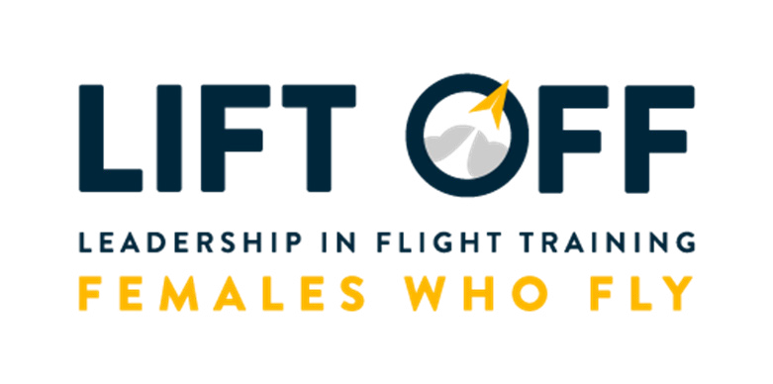
Welcome to our all virtual Girls in Aviation Day event, LIFT Off, Females Who Fly 2020! LIFT Off content can be accessed at www.flywithlift.com/liftoff!

We are so happy you have joined us and we’re excited for everything you will learn from our awesome, inspirational “panelists” who have a wide range of jobs in aviation. We have a few CEOs, a few airline captains and first officers, a lawyer, maintenance technicians, an engineer, educators, an author, a flight attendant and more! There is sure to be a career that you’ll be interested in learning more about at LIFT Off.

AND there is a scavenger hunt! The prizes are listed out below and are tiered! The more questions you answer, the more prizes you will earn! The scavenger hunt questionnaire is on the second page of this PDF. You’ll want to make sure you fill out the top of the second page in full to ensure that we can send you the prizes you earned! Once you finish answering the questions you want to answer, save, scan or take a photo of your responses and email to explore@flywithlift.com.

LIFT OFF SC A VENGER HUNT TIERS

For the scavenger hunt, YOU decide how many questions to answer, earning different levels of prizes! We have 15 different speakers for LIFT Off, and you can answer questions for one of the speakers all the way to all 15 speakers!
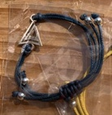
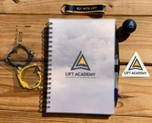
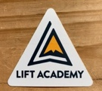
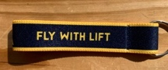
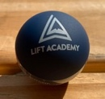
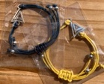
REGISTRATION
Access to the LIFT Off landing page, four motivational messages from LIFT over the next year and a bracelet
ONE SPEAKER Two bracelets
5 SPEAKERS Two bracelets, a key chain and a LIFT sticker
10 SPEAKERS
Two bracelets, a key chain, a LIFT sticker and a LIFT chapstick
15 SPEAKERS
Two bracelets, a key chain, a LIFT sticker, a LIFT chapstick and LIFT notebook

FIRST NAME:
SCAVENGER HUNT FORM

LAST NAME:

EMAIL ADDRESS: ADDRESS 1:

ADDRESS 2:

CITY: STATE:

ZIP OR POSTAL CODE: COUNTRY:
Email your completed scavenger hunt form to explore@flywithlift.com

“Panelist” | Question | Answer
Alexis Potter | Who got Alexis interested in aviation?
Andrea Santizo | Which pilot rating did Andrea recently receive?
Camila Turrieta | Camila flies for which airline?
Candace McGraw | What Bachelor’s degree does Candace hold?
Christy Perez Vasquez | What was Christy’s job before she became an AMT Apprentice at LIFT Academy?
Faye Malarkey Black | How many years has Faye been working in lobbying and advocacy?
Kelly Jost | Who is someone that inspired Kelly?
Kid Panel - Eden | What is the bravest thing Eden has done?
Lauren Pruitt | Where is Lauren based out of for work?
Lori McGee | How many jobs in aviation did Lori have before deciding to go to law school?
Peggy Chabrian | What is one of Peggy’s favorite things?
Rachel Rae | How long has Rachel been with Republic?
Tammie Jo Shults | What branches of the U.S. Armed Forces did Tammie Jo approach to become a pilot?
Trish Gilbert | What percent of air traffic controllers in 1989 were women?
Veronica Leacock Jimenez | What type of license does Veronica have?

